Standard Operating Procedure – Income Certificate Service

2021

Contents

Introduction 2

Eligibility Criteria 2

Documents required 2

Modes for submission of application 3

A. Online Application submission procedure 3

B. Submission of Application through Sewa Kendra 6

Fees for Income certificate: 8

Sample Acknowledgement Receipt 9

Sample certificate 10

Contact Details 11

| VERSION HISTORY | | | | |
| --- | --- | --- | --- | --- |
| VERSION | APPROVED BY | REVISION DATE | DESCRIPTION OF CHANGE | AUTHOR |
| 1.0 |  | 01/11/2021 |  | Ishan Rana |
|  |  |  |  |  |

# **Introduction**

To facilitate the public, Department of Governance Reforms & Public Grievances has digitized the process of “issuance of Income certificate” and now service will be available through [https://[eservices.punjab.gov.in](http://www.eservices.punjab.gov.in)](https://eservices.punjab.gov.in) web-portal, developed by National Informatics Center (NIC) Punjab.

Income Certificate is an essential document for those who expects any financial assistance through Govt. schemes or seat reservation in education programs. Income Certificate is a documentary proof declaring a person's or a family's annual income from all sources including salary, daily wages, pension, business, produces from property, rent, and remittances from expatriate member. It's an official document and proof of income of a person or family, issued by a Govt. authority.

This document will help the stakeholders to understand the process for smooth service delivery to the applicant.

# **Eligibility Criteria**

As per the letter no. 25/27/2011-ਭਮ-2/8158-8351 dated 27/05/2013 issued by the Department of Revenue, Rehabilitation and Disaster Management, Any person who is a[resident](https://www.indiafilings.com/learn/punjab-domicile-certificate/) of Punjab state is eligible to apply for an income certificate.

Documents required

| **S no** | **List of documents** |
| --- | --- |
| **1.** | ID cum residence Proof of Beneficiary * (Aadhar Card/Driving License/Passport/Voter Card/Govt. ID Card) * |
| **2.** | Photo of Beneficiary |
| **3.** | Self-Declaration * |
| **4.** | Verification Report * |
| **5.** | A copy of Proof of Income details from all sources or any other documents related to income |

# **Modes for submission of application**

Applicants, who is a[resident](https://www.indiafilings.com/learn/punjab-domicile-certificate/) of Punjab state and want to obtain an income certificate, may submit his/her application by using any of the following touchpoints:

1. Online touchpoint, by visiting [https://[eservices.punjab.gov.in](http://www.eservices.punjab.gov.in)](https://eservices.punjab.gov.in)
2. Physical touchpoint, by visiting nearest Sewa Kendra.

# **A. Online Application submission procedure**

To apply online by himself/herself, the applicant may visit [https://eservices.punjab.gov.in](https://eservices.punjab.gov.in/) or can search the link at [https://punjab.gov.in](https://punjab.gov.in/)

**Applicant is required to follow, below mentioned steps carefully to complete his/her online application:**

1. If the applicant is accessing the Income Certificate service for the first time, he/she will have to register and provide all required details, after which he/she would be issued ID/ Password.
2. Applicant shall have to register by clicking on the link “*Register yourself*” at the homepage of website.
3. After successful registration, click on “Login” link and type “username” and ‘password” to access the application form.
4. After login, applicant shall manage or update his/her profile that will help to fetch the basic details when applicant will fill online form to avail any service.
5. Next click on the link “*Apply for the services*” to select the desired service.
6. After completing the application form and filling all details then click on the “*Submit*” button to proceed next.
7. Next the applicant shall scan and attach supporting documents (Documents to be scanned from the original). Then click on “*make a payment*” button to complete the application.
8. Applicant shall pay Rs. 75/- to avail the Income Certificate service. Applicant shall pay the fee by online mode like internet banking, Debit card, UPI etc.
9. Once payment is successfully done, applicant shall receive acknowledgment via SMS & email.
10. Applicant may take printout of the acknowledgement receipt if required.
11. In case of payment transaction failure, click on the option “*Revalidate Payment*” on the left side of the menu to reconfirm the payment.
12. Applicant can track status of his application status by clicking on “*Check Your Application Status*” at homepage [https://[*eservices.punjab.gov.in*](http://www.eservices.punjab.gov.in)](https://eservices.punjab.gov.in)

* **All officials, involved in the processing of Income certificate service will use online login ID and password to process the application.**
* The procedure for processing of Income certificate application is as follows.

1. Once the application for issuance of Income certificate has been submitted on the service plus, the application will automatically forward to dealing clerk of the concerned Tehsildar / Naib-Tehsildar.
2. Dealing clerk shall log into his/ her account daily, to check the applications received. He/she shall examine the complete application details, check the supporting documents based on which he/she will enter his remarks and forward it to Tehsildar/Naib-Tehsildar.
3. In case of any discrepancy, he/she may send back the application to previous stage to clear the discrepancy. Applicant shall again resubmit the application after clearing the objection.
4. Tehsildar/Naib- Tehsildar shall log into his/ her account daily, to check the applications received. He/she shall examine the complete application details, check the supporting documents and remarks of the dealing clerk by clicking on view history. As per his/her observations he/she may take any of the following actions:
5. If he/she is satisfied with the details, he/she will approve the request using digital signature after entering his/her remarks.
6. If he/she is not satisfied, he/she may reject the service request after entering his/her remarks.
7. If he/she find any discrepancy in data, he may send back the application after entering his/her remarks.
8. in case of any discrepancy over the claim of the Applicant, may mark the application to concerned dealing clerk for carrying out verification of the applicant.
9. Applicant shall also receive mail / SMS regarding approval or rejection
10. In case of approval, applicant can download his/her certificate by login in his/her ID or click on the link “*Verify Your Certificate*” at the home page of the website. Applicant can also download the certificate from the link received through SMS.
11. Downloaded certificate is digitally signed by the approving authority, so there is no need of hologram or any manual stamp on the certificate.
12. Contents of the certificate can be verified at the [https://[eservices.punjab.gov.in](http://www.eservices.punjab.gov.in)](https://eservices.punjab.gov.in)

# **B. Submission of Application through Sewa Kendra**

**Applicant need to follow below mentioned steps to submit his application through Sewa Kendra:**

1. To avail the service for issuance of Income certificate applicant may also visit his/her nearest Sewa Kendra along with application form and required documents.
2. Application form can be downloaded from [https://eservices.punjab.gov.in](https://eservices.punjab.gov.in/) and  [https://punjab.gov.in](%20https://punjab.gov.in) free of cost or can be obtained from Sewa Kendra by paying charges of Rs.1 per page. If any applicant require help in filling the application form, he/she may avail form filling service by paying Rs. 10 (for 1st page) + Rs. 5 (for remaining pages) at Sewa Kendra.
3. The authorized Sewa Kendra operator after receiving the request shall login into the service plus application using his operator ID & Password and select the service of Issuance of Income Certificate.
4. The authorized Sewa Kendra operator will fill up the online form with the details provided by the applicant.
5. The authorized Sewa Kendra operator will then take a photograph of the applicant using a web camera attached with his workstation.
6. The authorized Sewa Kendra operator should scan any supporting documents (form original document) provided by the applicant and upload the same online.
7. Before submitting the application, operator may get the details verified form the applicant.
8. Applicant will pay the specified fees in cash to the authorized Sewa Kendra operator.
9. The authorized Sewa Kendra operator will collect the specified amount of fees and enter its details in the service plus application.
10. A unique application ID will be generated automatically.
11. The authorized operator will print the acknowledgment receipt, sign it and handover to the applicant.
12. Applicant can track status of his application status by clicking on “*Check Your Application Status”* at [https://[eservices.punjab.gov.in](http://www.eservices.punjab.gov.in)](https://eservices.punjab.gov.in)
13. The Authorized Sewa Kendra operator will return the physical file to applicant.
14. Once the application for issuance of Income certificate has been submitted on the service plus, the application will automatically be forwarded to the dealing clerk of the concerned Tehsildar / Naib-Tehsildar.
15. Dealing clerk will log into his/ her account daily, to check the applications received. He/she shall examine the complete application details, based on which he/she will enter his remarks and forward it to Tehsildar/Naib-Tehsildar.
16. In case of any discrepancy, he/she may send back the application to previous stage to clear the discrepancy. Sewa Kendra operator shall again resubmit the application after clearing the objection.
17. The procedure for processing of Income certificate application will be same as mentioned in **para 12 at page 4.**
18. If application is approved by the concerned office, then applicant can download his/her certificate or clicking on the link “Verify Your Certificate” at the home page of the website. Applicant can also download the certificate from the link received through SMS or visit the Sewa Kendra to get his certificate.
19. Downloaded certificate is digitally signed by the approving authority so there is no need of hologram or any manual stamp on the delivery certificate.
20. Contents of the certificate can be verified at the [https://[eservices.punjab.gov.in](http://www.eservices.punjab.gov.in)](https://eservices.punjab.gov.in)

# **Fees for Income certificate:**

1. The total fee for Income certificate service is Rs 75/- (Facilitation fee).
2. In case of online application procedure, there are different payments gateway available and charges are as follow:

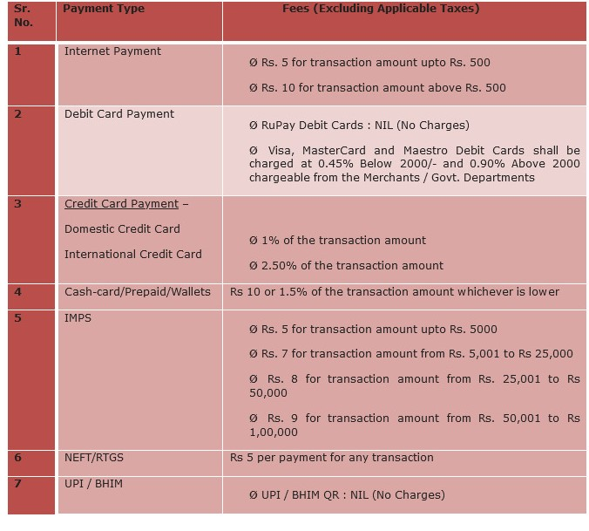

1. In case of Sewa Kendra, fees to be collected in cash.

# **Sample Acknowledgement Receipt**

85

# 

# **Sample certificate**

# **Contact Details**

For any query or feedback or complaint applicant may contact via call or email.

|  |  |
| --- | --- |
|  | **1100** |
|  | [**Complaint.sewakendra@gmail.com**](mailto:Complaint.sewakendra@gmail.com) |